**Josh Williams** [jswilliams@paulding.k12.ga.us](mailto:jswilliams@paulding.k12.ga.us)

**Troy Stone** [tstone@paulding.k12.ga.us](mailto:tstone@paulding.k12.ga.us)

**Course Description**

This is a third year mathematics course designed to prepare students for calculus and similar college mathematics courses. It requires students to:

* analyze and use trigonometric functions, their graphs, and their inverses;
* use trigonometric identities to solve problems and verify equivalence statements;
* solve trigonometric equations analytically and with technology;
* find areas of triangles using trigonometric relationships;
* perform operations on matrices, use matrices in applications and solving systems of equations
* derive the equations of conic sections (parabolas, ellipses, and hyperbolas)
* understand and use vectors, perform operations with vectors;
* computing and interpreting probabilities of compound events;
* calculate expected values and use them to solve problems and make informed decisions

**Topics**

|  |  |
| --- | --- |
| * Introduction to Trigonometric Functions | * Matrices |
| * Trigonometric Functions | * Conics |
| * Trigonometry of General Triangles | * Vectors |
| * Trigonometric Identities | * Inferences & Conclusions from Data * Probability |
|  |  |

**Notebook and supplies**

You need to keep a notebook. At 1 1/2-inch, (or larger) 3-ring binder would be the preferred option (recommended). Paper and a writing utensil (preferably a pencil ).

[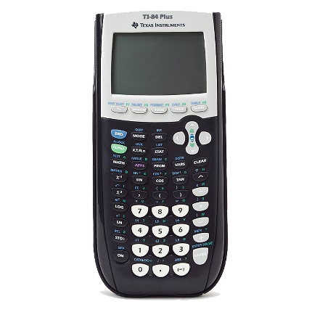](http://www.google.com/url?sa=i&rct=j&q=&esrc=s&frm=1&source=images&cd=&cad=rja&uact=8&ved=0CAcQjRxqFQoTCJCp6qv4gMcCFZcPkgodSnkKRw&url=http://www.amazon.com/Texas-Instruments-TI-84-Graphing-Calculator/dp/B0001EMM0Q&ei=aRe5VdDQEpefyATK8qm4BA&bvm=bv.99028883,d.aWw&psig=AFQjCNGrRY4QPn15G3AXpXk2V2PB8lTK-A&ust=1438279909424840)**Calculator: TI-84 Plus (recommended)**

|  |  |
| --- | --- |
| **Grading :**  View grades daily at [www.paulding.k12.ga.us](http://www.paulding.k12.ga.us)  Parent Portal | Formative - 23% |
| Summative - 57% |
| Final/Mid-term exam - 20% |
|

You must be able to do trigonometric functions on your calculator (sine, cosine, and tangent). Due to the limited number of classroom calculators, you may not be guaranteed use of a scientific or graphing calculator.

**Final Exam**

The Final exam will be given at the conclusion of the semester and it is a cumulative test covering all concepts of the course.

**Performance Tasks**

“P.T’s” will be done alone, in pairs, and in groups during each unit. These tasks will be used as a tool to help you acquire the math content in the course. You will be asked to present your work during class and will be given frequent quizzes to encourage you to use your time in class to the fullest.

**Homework**

Like the performance tasks, homework will be assigned as a tool to help you to acquire math content, to help you develop confidence in problem solving, and to help you develop your math skills. *If you do not complete the assigned homework, do not expect to do well in this class.*

**Extra credit**

Strictly speaking there is no extra credit in this class. At my discretion, a few assignments and tests may have a few bonus points. ***Do not expect extra credit to alter your grade at the end of the semester.***

**Attendance and makeup work**

Attendance is an extremely important part of this class. Your success depends on your being in class every day. If you are absent it is your responsibility to get the notes and assignments that are missed***. If you are absent, you will follow the Paulding County School District policy regarding makeup assignments.*** Missed tests can be made up before or after school ***by making prior arrangements with me.*** **\*\*PLEASE NOTE:** **Per county and school policy, if you are absent, you have 3 days to provide an excuse note. *If you do not provide one, I do not have to let you make up your work*. It is SO important to be in school and in class in order to be successful your junior/senior year.**

**Recovery Policy:**

Remediation and recovery on **up to 3 Summative Assessments** are offered within a two-week time frame after the student received the assessment grade, but only after the student has completed required remediation. Remediation will be done on iXL online. Standards will be assigned for the unit they wish to recover. After remediation the student will need to email or see the teacher for the day and time to recover the test. Students may also benefit from before or after school tutoring. Students will have the opportunity to replace the test grade up to a 75. All remediation and recovery must be scheduled outside the school day, and it is the student’s responsibility to coordinate transportation to and from school in order to complete the remediation and recovery.

**Class rules** 1. Be ready. 2. Be respectful. 3. Be responsible.

**Be ready** means that you will bring your materials to class everyday (paper, pencil, notebook,

textbook, calculator, etc.) and that you will do your homework and study for quizzes and tests.

**Be respectful** means that you will respect the teacher, other students, materials, and the curriculum.

**Be responsible** means that you are responsible for the grade you earn in class and for the behavior you put forth in this class. You earn your grade and you earn any discipline measures I provide.

**Consequences** for failing to follow class rules will result in a verbal warning, then a phone call or email to your parent/guardian and/or a referral to the appropriate administrator.

**Tutoring schedule**: Tutoring will be offered and the schedule will be posted, as soon as it is finalized, in the classroom and on my canvas. Students are welcome in tutoring whenever they feel that they need it. It will also be available on the SPHS website.